Option Prices under Bayesian Learning: Implied Volatility Dynamics and Predictive Densities.

Guidolin and Timmermann

Nicholas Lyle

A01757213

Fin6470

There are many known problems with the Black-Scholes model that have been proven since its inception. Firstly it has empirical bias. We also see asymmetric skewness in the implied volatility surface and systematic patterns in the term structure of the option prices. In this paper they use Baysian learning to create model that is more accurate that the Black-Scholes model and others that have tried to fix it’s flaws. In addition to being more accurate it also serves the purpose of providing economic explanation for the limitations of the Black-Scholes model.

They use a binomial model much the same as the binomial option-pricing model. They use this type of structure in an equilibrium model to digest dividend news on the nodes. The probabilities of the nodes are unknown but they are being recursive on the lattice to derive closed form solutions. In the paper the authors relax the full information constraint to fit Bayes rule. They use Bayes rule to estimate the probabilities of the up and down movements on the binomial tree. This is a more credible representation to how option pricing works in the real world. Assuming in the real world that all information is not available to investors.

However, simply replacing the assumptions of Black-Scholes model of up and down probabilities produces its own bias inside the Bayesian learning model that are close to the biases in the option pricing model. Bayesian learning alters the shape of the state price density and adding to tail probabilities. It also can generate implied volatility smiles. They solve these problems in the paper by inverting the model. Doing this along with some other error correcting ideas shows stability in the parameters and also smaller hedging errors. The throw out the rest of the options.

Preconceptions in the Black-Scholes Model

The authors of the paper look at a few different things to first understand what biases there are in the Black-Scholes model. They observed weekly option prices over a five-year period (June 1988 – December 1993). They looked at options that were longer than six days but less than 200. They also eliminate in the in the money options that have a low trade volume just to be sure they are looking at liquid put and call prices. If the put prices are out of the money they are converted to calls using the put-call parity. When enacting these restrictions this reduces their sample size to 9,679 observations.

In the paper they acknowledge the systematic skew in the relationship between Black-Scholes implied volatility and moneyness. They plot the implied volatility surface against moneyness to show this skewness (shown in figure 1 below). This goes against the assumption of constant diffusion in the Black-Scholes model.

Figure 1.

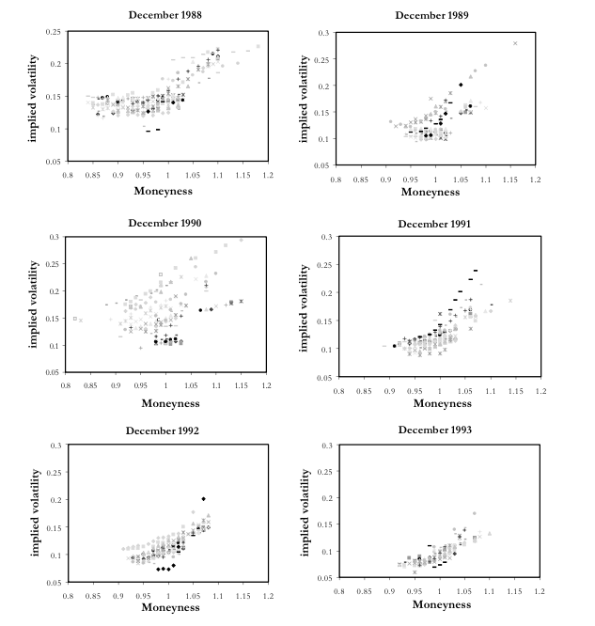

The authors of this paper use a proposition from Rubinstein (1994) and Jackwerth and Rubinstein (1996) to extract state price densities (SPD) from the implied binomial trees. They cite these in their paper to show more biases in the Black-Scholes model. The Black-Scholes model makes the assumption that state price dependencies are lognormal. When they used the lognormal benchmark they observe, particularly, the tail risk of these distributions that could provide more insight to jump risks associated with the Black-Scholes model. When they lay the SPD of the S&P data over the lognormal benchmark it is very clear that it is leptokurtic and not normal. These findings support the notion that there are systematic biases in the Black-Scholes model. This suggests that there needs to be a more general option-pricing model. They go on to explore some options to accomplish this.

In the paper they go on to talk about five different propositions to lay down the fundamentals of their model. They start by looking at three assets which they assume have and infinite horizon. The three assets are: a one –period default-free zero coupon bond in zero net supply trading at a price of B_t and earning interest of (1/B_t -1), ja stock traded at a price of S_t whose net supply is normalized at 1, and a European call option written on stock T-t periods a strike price of K and a current price C_t. The stock also pays dividends that are non-negative that follows a Bernoulli process. To price the assets they assume perfect capital markets, unlimited short sales, perfect liquidity, no taxes, no transactions costs, and markets are open at all nodes where dividend news is created.

The use a full information rational expectations stock price in the first assumption the property of this is that the stock price is homogenous of degree one in dividend and the ex-dividend stock price follow the same binomial lattice as the dividends one. This means that dividends and stock prices follow a stationary Markov chain.

They also examine option prices under full information. Pricing the European call options is what provides the link to Black-Scholes. This is a straightforward process. Some assumptions that the authors make in their model are: arbitrage opportunities are ruled out, markets are complete, ex-dividend stock prices inherit the binomial structure, and even though the stock pays dividends the European option under definition can not be exercised early. Referring to their model in the paper they claim that as m approaches infinite the price of the option converge with the Black-Scholes price which we proved in class. This leads into their second proposition in the paper to prove this where they scale the parameters.

They address the common assumption in asset pricing that people use a given process for the underlying asset price and then price the option as a redundant asset whose pay offs can be replicated in a dynamic hedging strategy involving a risky asset and a risk free bond. This assumes stationarity that does not incorporate a learning aspect to the asset price. To introduce a learning aspect to the asset price and equilibrium model for the underlying asset price must be created. This allows them to set up the learning effects that they describe in proposition 3. It is also worthy of note that the same assumptions from the simplified solution of asset pricing are still in use for this proposition. Proposition 3 proposes a stock price formula under Bayesian learning.

Proposition 3 gives us several implications. The price dividend ratio is no longer constant, dividends are self-enforcing, positive dividend shocks lead to an increase in the stock price.

The path dependence of this method mean that no arbitrage processes are more complicated when incorporating Bayesian learning. Regardless of this fact the authors present, in proposition 4, the formula for pricing the European call in this environment. When using these learning nodes we find that the stationary Markov chain is broken. This will determine how the risk-neutral distributions are updated. Using the computations that have been presented this far in the paper now require us to keep track of the risk free rate as we move along the dividend tree.

In their 5th and last proposition they attempt to explain the biases in the Black-Scholes model. When there is estimation uncertainty there is a reduction in the underlying asset price for investors that are a not over a certain level of risk aversion, but also increases the asset price through a positive covariance between future asset payoffs and beliefs. They also observe a level of asset prices is also established by comparing option prices under learning to the Black-Scholes option price. They graph the dollar difference between the Bayesian learning model with the Black-Scholes model and find that the dollar difference between the two respective models is positive assuming a zero strike price and increases dramatically over some higher strikes then drops back to zero. When the model is tested with option data market prices for European calls are systematically above the Black-Scholes model. There is also a smiling in implied volatility shape that suggests strong learning effects and that investors are at least a little optimistic.

After presenting these propositions they then go back and do the same analysis from the beginning of the paper for their Bayesian model. They revisit state price densities and term structure of implied volatilities. They also look at vanishing learning effects in their model and how this relates to the Black-Scholes price. The found that when learning effects are weak the Bayesian learning model price converges with the Black-Scholes model price. The authors expected this given how they constructed their model since the learning aspect is the only thing that is non-stationary compared to Black-Scholes. When option prices are smiles investors attach high precisions to their initial beliefs. To ensure that learning effects don’t disappear they simplify the model to assume that markets use a rolling window of data to estimate π. This has two consequences, first agents now form an estimate of the unknown parameter π based on their most recent observations and second, the more subtle complicated of the two, is when agents form perceptions of the probability distribution of future dividend levels on the binomial lattice, they have to integrate over all the possible future perceptions. The second accounts replaces past observations with future realizations.

To sum up, the reason for the paper is to integrate Bayesian learning into the Black-Scholes model to look for biases and find truer asset prices under an equilibrium model. From the empirical findings in the paper it looks that they were successful in identifying biases in the Black-Scholes model and had effective accuracy in creating a hedging strategy for the underlying assets of the options they observed.